## **Week 4 Homework Submission File: Linux Systems Administration**

### **Step 1: Ensure/Double Check Permissions on Sensitive Files**

1. Permissions on /etc/shadow should allow only root read and write access.  
   * Command to inspect permissions:

ls -l /etc/shadow

* + Command to set permissions (if needed):

File permission shows that only root has read and write permission for /etc/shadow. There is no need to change the permission using chmod command.

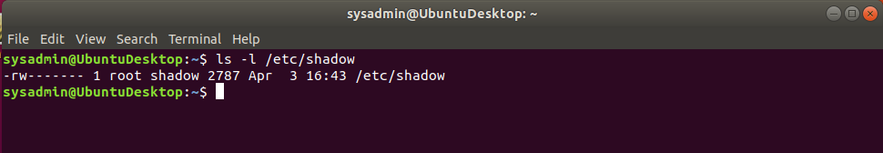

1. Permissions on /etc/gshadow should allow only root read and write access.  
   * Command to inspect permissions:

ls -l /etc/gshadow

* + Command to set permissions (if needed):

File permission shows that only root has read and write permission for /etc/shadow. There is no need to change the permission using chmod command.

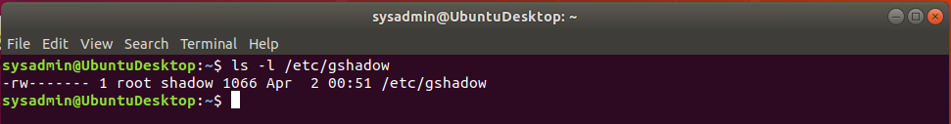

1. Permissions on /etc/group should allow root read and write access, and allow everyone else read access only.  
   * Command to inspect permissions:

ls -l /etc/group

* + Command to set permissions (if needed):

File permission shows that root has read and write permission and everyone else has read permission only. There is no need to change the permission using chmod command.

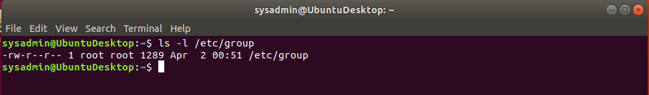

1. Permissions on /etc/passwd should allow root read and write access, and allow everyone else read access only.  
   * Command to inspect permissions:

ls -l /etc/passwd

* + Command to set permissions (if needed):

File permission shows that root has read and write permission and everyone else has read permission only. There is no need to change the permission using chmod command.

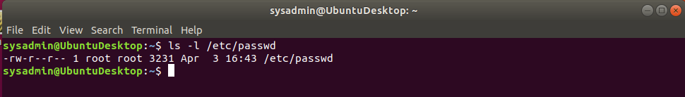

### **Step 2: Create User Accounts**

1. Add user accounts for sam, joe, amy, sara, and admin.  
   * Command to add each user account (include all five users):

sudo adduser sam

sudo adduser joe

sudo adduser amy

sudo adduser sara

sudo adduser admin

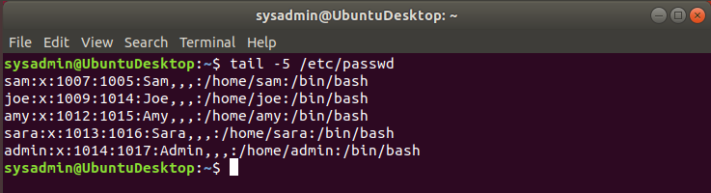

*Note: One can also create a user with --no-create-home flag which creates no home folder for the user . By default, a folder in the home folder is created with the same name as that of the user in /home when sudo adduser <user name> is executed.*

1. Ensure that only the admin has general sudo access.

User account ‘admin’ already has the permission to run any command with sudo because group ‘admin’ has an entry in the sudoers file (/etc/sudoers) which allows all members of the ‘admin’ group to run any command with sudo. It is to be noted that the ‘admin’ user became a member of ‘admin’ group when it was created.

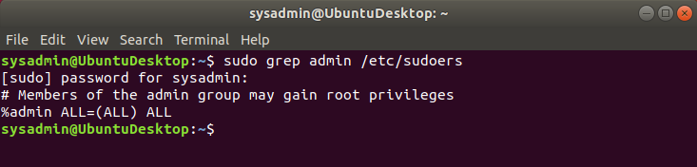

* + Command to add admin to the sudo group:

sudo usermod -aG sudo admin

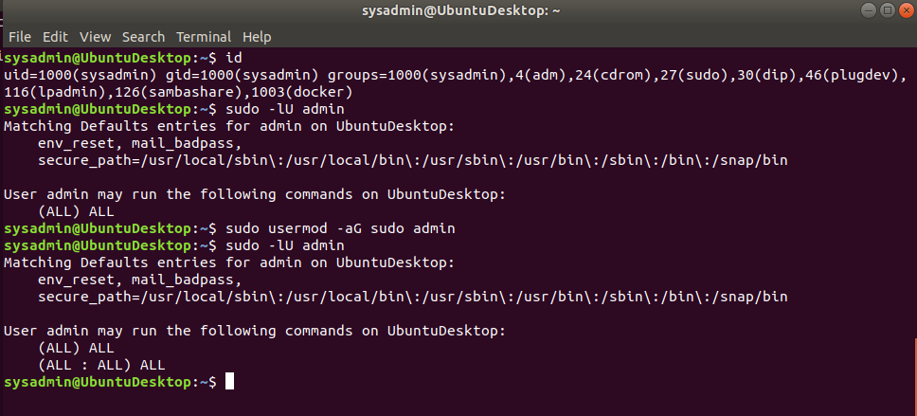

### ***Note::*** *This 'admin' group was already included in the /etc/sudoers file that provided 'admin' user permission to run ALL commands using sudo. [(ALL) ALL]*

### *When we ran the "sudo usermod -aG sudo admin", we again added this user 'admin' to 'sudo' group that once again provided the same permission to run all commands using sudo [(ALL : ALL) ALL]*

### **Step 3: Create User Group and Collaborative Folder**

1. Add an engineers group to the system.  
   * Command to add group:

sudo addgroup engineers

1. Add users sam, joe, amy, and sara to the managed group.  
   * Command to add users to engineers group (include all four users):

sudo usermod -aG engineers sam

sudo usermod -aG engineers joe

sudo usermod -aG engineers amy

sudo usermod -aG engineers sara

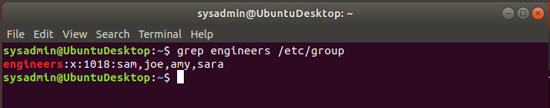

1. Create a shared folder for this group at /home/engineers.  
   * Command to create the shared folder:

sudo mkdir /home/engineers

1. Change ownership of the new engineers' shared folder to the engineers group.  
   * Command to change ownership of engineer's shared folder to engineer group:

sudo chown :engineers /home/engineers

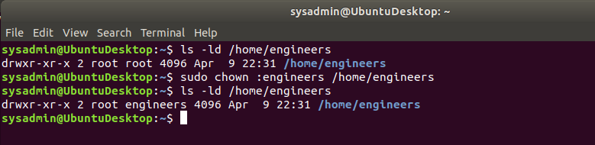

### **Step 4: Lynis Auditing**

1. Command to install Lynis:

sudo apt install lynis  
Please note that lynis was already installed on my Ubuntu Linux Desktop

1. Command to see documentation and instructions:

man lynis

1. Command to run an audit:

sudo lynis audit system

1. Provide a report from the Lynis output on what can be done to harden the system.  
   * Screenshot of report output:

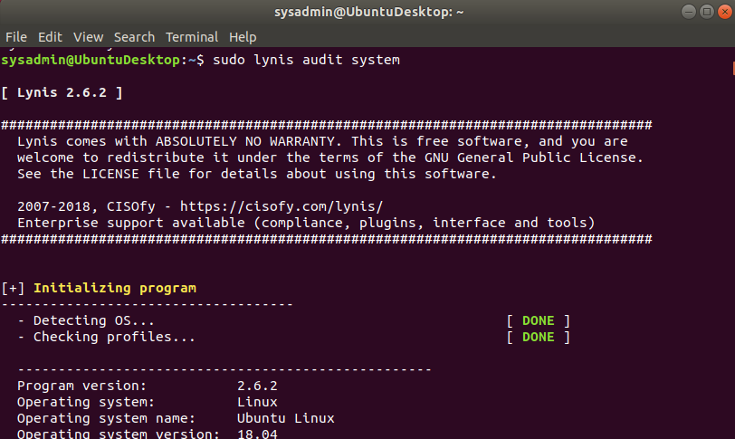

### 

### 

### 

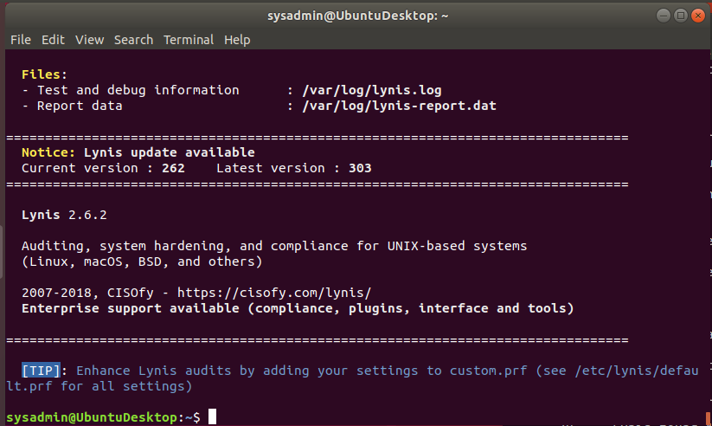

### *After running the lynis command, I attached some screenshots(partial) of the output. In addition, I reviewed the details provided by the lynis audit command, and I am including the following recommendations to harden this Linux desktop.*

***Source : Copied from the output provided by the lynis audit command***

================================================================================

-[ Lynis 2.6.2 Results ]-

Warnings (5):

----------------------------

! Version of Lynis is very old and should be updated [LYNIS]

https://cisofy.com/controls/LYNIS/

! No password set for single mode [AUTH-9308]

https://cisofy.com/controls/AUTH-9308/

! Found one or more vulnerable packages. [PKGS-7392]

https://cisofy.com/controls/PKGS-7392/

! Found some information disclosure in SMTP banner (OS or software name) [MAIL-8818]

https://cisofy.com/controls/MAIL-8818/

! Found one or more cronjob files with incorrect ownership (see log for details) [SCHD-7704]

https://cisofy.com/controls/SCHD-7704/

Suggestions (53):

----------------------------

* Install libpam-tmpdir to set $TMP and $TMPDIR for PAM sessions [CUST-0280]

https://your-domain.example.org/controls/CUST-0280/

* Install libpam-usb to enable multi-factor authentication for PAM sessions [CUST-0285]

https://your-domain.example.org/controls/CUST-0285/

* Install apt-listbugs to display a list of critical bugs prior to each APT installation. [CUST-0810]

https://your-domain.example.org/controls/CUST-0810/

* Install apt-listchanges to display any significant changes prior to any upgrade via APT. [CUST-0811]

https://your-domain.example.org/controls/CUST-0811/

* Install debian-goodies so that you can run checkrestart after upgrades to determine which services are using old versions of libraries and need restarting. [CUST-0830]

https://your-domain.example.org/controls/CUST-0830/

* Install needrestart, alternatively to debian-goodies, so that you can run needrestart after upgrades to determine which daemons are using old versions of libraries and need restarting. [CUST-0831]

https://your-domain.example.org/controls/CUST-0831/

* Install debsecan to generate lists of vulnerabilities which affect this installation. [CUST-0870]

https://your-domain.example.org/controls/CUST-0870/

* Install debsums for the verification of installed package files against MD5 checksums. [CUST-0875]

https://your-domain.example.org/controls/CUST-0875/

* Install fail2ban to automatically ban hosts that commit multiple authentication errors. [DEB-0880]

https://cisofy.com/controls/DEB-0880/

* Set a password on GRUB bootloader to prevent altering boot configuration (e.g. boot in single user mode without password) [BOOT-5122]

https://cisofy.com/controls/BOOT-5122/

* Run pwck manually and correct any errors in the password file [AUTH-9228]

https://cisofy.com/controls/AUTH-9228/

* Install a PAM module for password strength testing like pam_cracklib or pam_passwdqc [AUTH-9262]

https://cisofy.com/controls/AUTH-9262/

* Configure minimum password age in /etc/login.defs [AUTH-9286]

https://cisofy.com/controls/AUTH-9286/

* Configure maximum password age in /etc/login.defs [AUTH-9286]

https://cisofy.com/controls/AUTH-9286/

* Set password for single user mode to minimize physical access attack surface [AUTH-9308]

https://cisofy.com/controls/AUTH-9308/

* Default umask in /etc/login.defs could be more strict like 027 [AUTH-9328]

https://cisofy.com/controls/AUTH-9328/

* To decrease the impact of a full /home file system, place /home on a separated partition [FILE-6310]

https://cisofy.com/controls/FILE-6310/

* To decrease the impact of a full /tmp file system, place /tmp on a separated partition [FILE-6310]

https://cisofy.com/controls/FILE-6310/

* To decrease the impact of a full /var file system, place /var on a separated partition [FILE-6310]

https://cisofy.com/controls/FILE-6310/

* Disable drivers like USB storage when not used, to prevent unauthorized storage or data theft [STRG-1840]

https://cisofy.com/controls/STRG-1840/

* Check DNS configuration for the dns domain name [NAME-4028]

https://cisofy.com/controls/NAME-4028/

* Purge old/removed packages (1 found) with aptitude purge or dpkg --purge command. This will cleanup old configuration files, cron jobs and startup scripts. [PKGS-7346]

https://cisofy.com/controls/PKGS-7346/

* Install debsums utility for the verification of packages with known good database. [PKGS-7370]

https://cisofy.com/controls/PKGS-7370/

* Update your system with apt-get update, apt-get upgrade, apt-get dist-upgrade and/or unattended-upgrades [PKGS-7392]

https://cisofy.com/controls/PKGS-7392/

* Install package apt-show-versions for patch management purposes [PKGS-7394]

https://cisofy.com/controls/PKGS-7394/

* Consider running ARP monitoring software (arpwatch,arpon) [NETW-3032]

https://cisofy.com/controls/NETW-3032/

* Access to CUPS configuration could be more strict. [PRNT-2307]

https://cisofy.com/controls/PRNT-2307/

* You are advised to hide the mail_name (option: smtpd_banner) from your postfix configuration. Use postconf -e or change your main.cf file (/etc/postfix/main.cf) [MAIL-8818]

https://cisofy.com/controls/MAIL-8818/

* Disable the 'VRFY' command [MAIL-8820:disable_vrfy_command]

- Details : disable_vrfy_command=no

- Solution : run postconf -e disable_vrfy_command=yes to change the value

https://cisofy.com/controls/MAIL-8820/

* Check iptables rules to see which rules are currently not used [FIRE-4513]

https://cisofy.com/controls/FIRE-4513/

* Install Apache mod_evasive to guard webserver against DoS/brute force attempts [HTTP-6640]

https://cisofy.com/controls/HTTP-6640/

* Install Apache modsecurity to guard webserver against web application attacks [HTTP-6643]

https://cisofy.com/controls/HTTP-6643/

* Add HTTPS to nginx virtual hosts for enhanced protection of sensitive data and privacy [HTTP-6710]

https://cisofy.com/controls/HTTP-6710/

* Consider hardening SSH configuration [SSH-7408]

- Details : AllowTcpForwarding (YES --> NO)

https://cisofy.com/controls/SSH-7408/

* Consider hardening SSH configuration [SSH-7408]

- Details : ClientAliveCountMax (3 --> 2)

https://cisofy.com/controls/SSH-7408/

* Consider hardening SSH configuration [SSH-7408]

- Details : Compression (YES --> (DELAYED|NO))

https://cisofy.com/controls/SSH-7408/

* Consider hardening SSH configuration [SSH-7408]

- Details : LogLevel (INFO --> VERBOSE)

https://cisofy.com/controls/SSH-7408/

* Consider hardening SSH configuration [SSH-7408]

- Details : MaxAuthTries (6 --> 2)

https://cisofy.com/controls/SSH-7408/

* Consider hardening SSH configuration [SSH-7408]

- Details : MaxSessions (10 --> 2)

https://cisofy.com/controls/SSH-7408/

* Consider hardening SSH configuration [SSH-7408]

- Details : PermitRootLogin (WITHOUT-PASSWORD --> NO)

https://cisofy.com/controls/SSH-7408/

* Consider hardening SSH configuration [SSH-7408]

- Details : Port (22 --> )

https://cisofy.com/controls/SSH-7408/

* Consider hardening SSH configuration [SSH-7408]

- Details : TCPKeepAlive (YES --> NO)

https://cisofy.com/controls/SSH-7408/

* Consider hardening SSH configuration [SSH-7408]

- Details : X11Forwarding (YES --> NO)

https://cisofy.com/controls/SSH-7408/

* Consider hardening SSH configuration [SSH-7408]

- Details : AllowAgentForwarding (YES --> NO)

https://cisofy.com/controls/SSH-7408/

* Check what deleted files are still in use and why. [LOGG-2190]

https://cisofy.com/controls/LOGG-2190/

* Add a legal banner to /etc/issue, to warn unauthorized users [BANN-7126]

https://cisofy.com/controls/BANN-7126/

* Add legal banner to /etc/issue.net, to warn unauthorized users [BANN-7130]

https://cisofy.com/controls/BANN-7130/

* Enable process accounting [ACCT-9622]

https://cisofy.com/controls/ACCT-9622/

* Enable sysstat to collect accounting (no results) [ACCT-9626]

https://cisofy.com/controls/ACCT-9626/

* Enable auditd to collect audit information [ACCT-9628]

https://cisofy.com/controls/ACCT-9628/

* Run 'docker info' to see warnings applicable to Docker daemon [CONT-8104]

https://cisofy.com/controls/CONT-8104/

* One or more sysctl values differ from the scan profile and could be tweaked [KRNL-6000]

- Solution : Change sysctl value or disable test (skip-test=KRNL-6000:<sysctl-key>)

https://cisofy.com/controls/KRNL-6000/

* Harden compilers like restricting access to root user only [HRDN-7222]

https://cisofy.com/controls/HRDN-7222/

Follow-up:

----------------------------

- Show details of a test (lynis show details TEST-ID)

- Check the logfile for all details (less /var/log/lynis.log)

- Read security controls texts (https://cisofy.com)

- Use --upload to upload data to central system (Lynis Enterprise users)

================================================================================

### **Bonus**

1. Command to install chkrootkit:

sudo apt install chkrootkit

Please note that chkrootkit package is already installed on my Ubuntu Linux Desktop

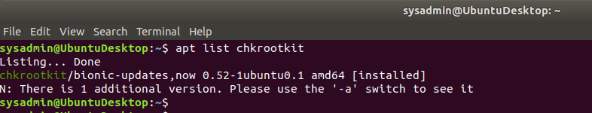

1. Command to see documentation and instructions:

man chkrootkit

1. Command to run expert mode:

sudo chkrootkit -x

1. Provide a report from the chrootkit output on what can be done to harden the system.  
   * Screenshot of end of sample output:

